## horizontal line



Lab2 - AWS Automation

2022-03-11

**─**

Colin Holman

Software Defined Networks

Repo: https://github.com/ColinHolman/Lab2_CHolman

# 

# The Infrastructure

I decided that I wanted to deploy a Load Balancer with 3 web servers through AWS. To achieve this, I would be using a controller node inside AWS as a controller EC@ instance. From there I would automate by creating three EC2 instances acting as web servers and creating an ELB.

# Network Topology

For my network Topology, I went with one Load Balancer and three web server instances.

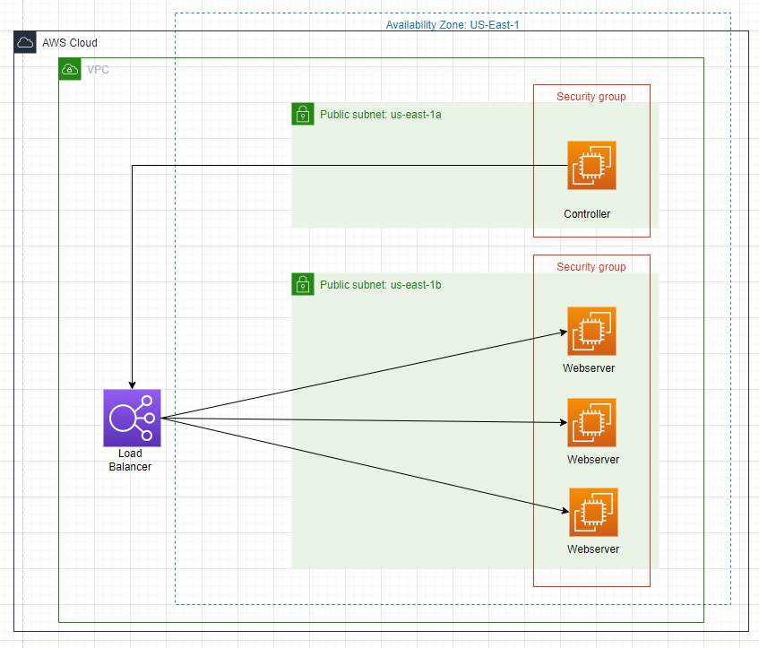

# Inventory

My inventory is very small. I am only using a local host. Since I SSH into my controller instance, all the work is done through the controller node.

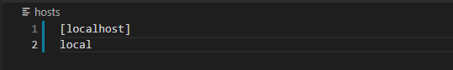

# Executing the playbook

Here is my tree. As you can see, I have 4 different files. My playbook file is **provision.yml**, my variables file is **grp_vars.yaml** and my facts playbook is **get_facts.yml**. To execute the provision playbook, I just use the **ansible-playbook provision.yml** command.

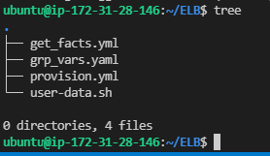

Here is the outcome of the playbook

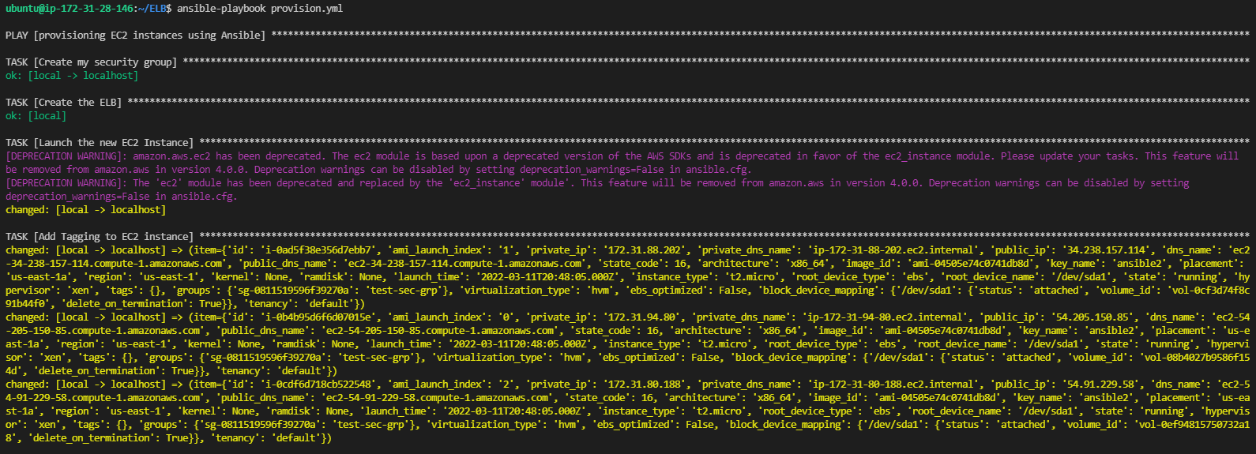

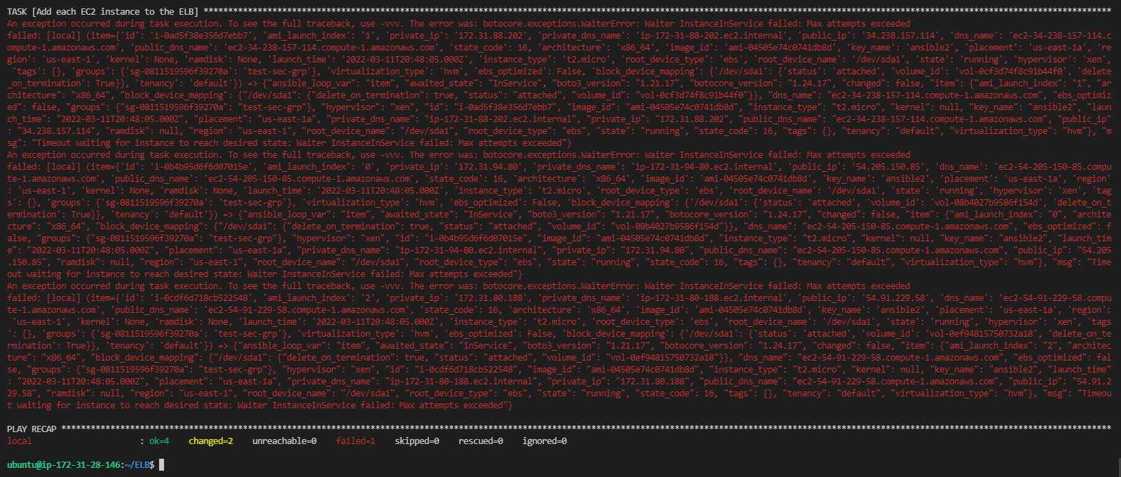

With that being said, I did run into an error with adding my EC2 instances tto my ELB. However, looking at my VPC, it was able to create them.

Here’s the web server instances created:



Here’s the Load Balancer create and attaching the web servers to it:

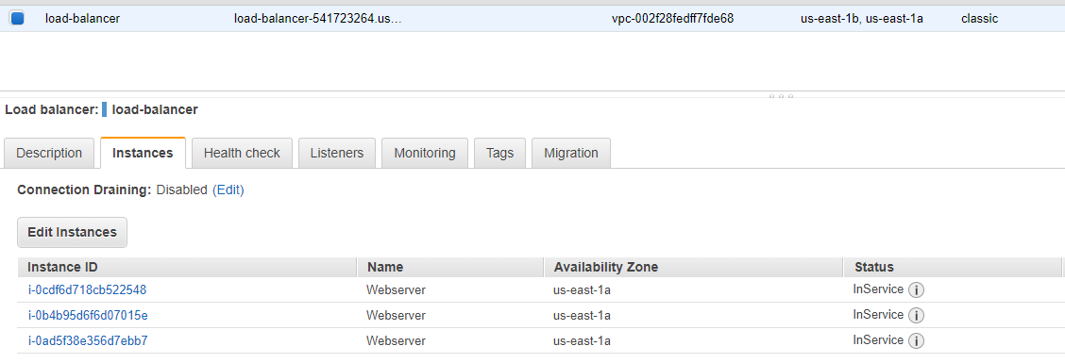

Here’s my Security Groups that were created:



Now executing the get facts playbook:

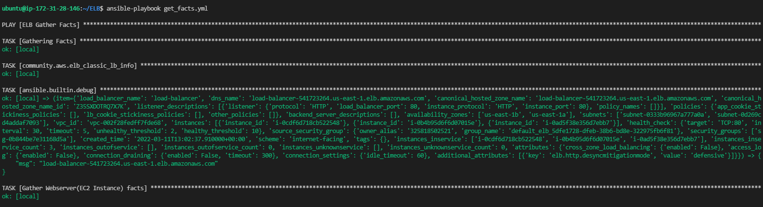

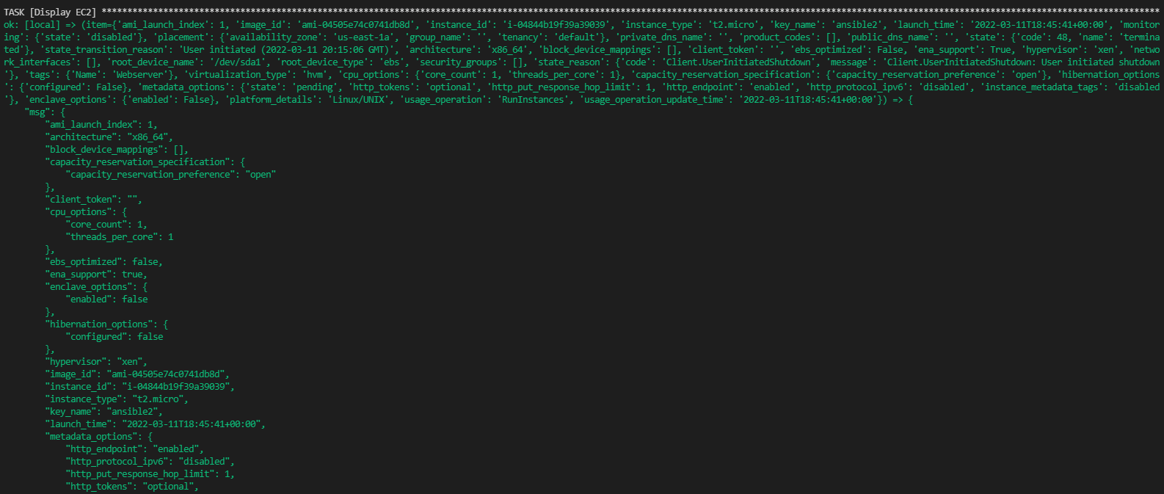

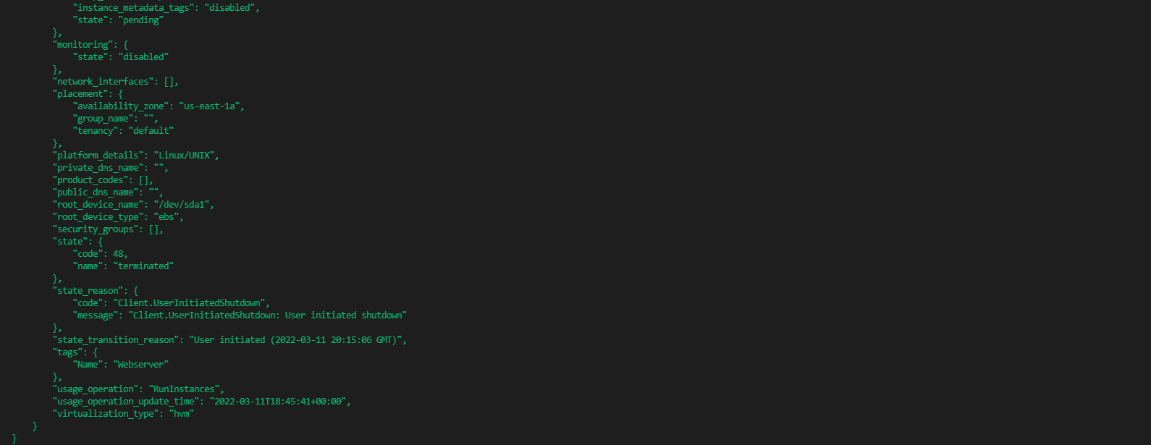

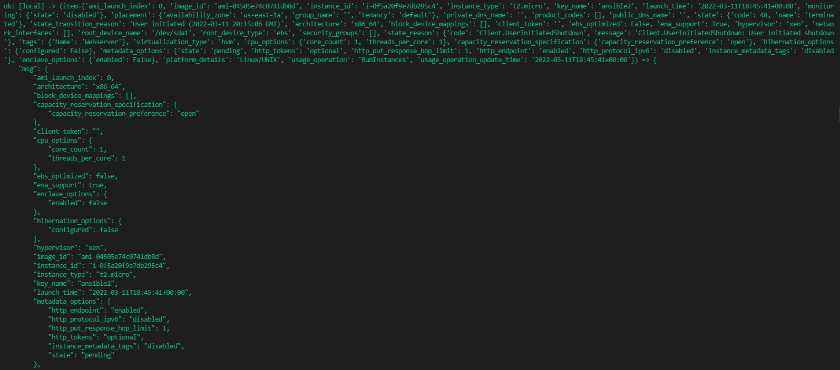

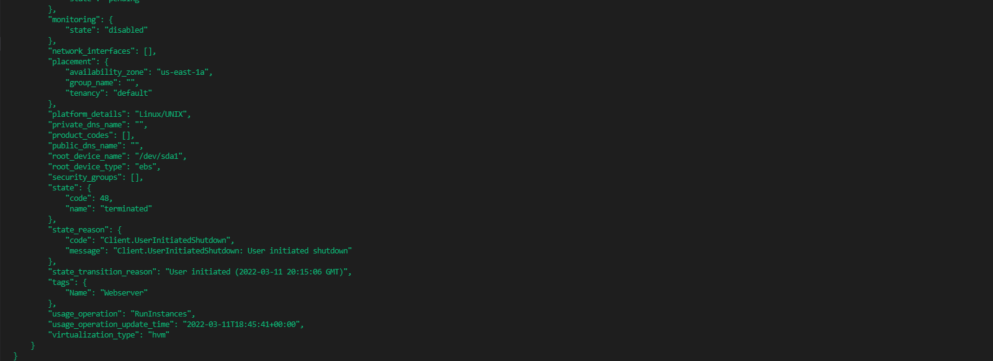

Proof of the Load Balancer working:







# The Playbooks

## Provision.yml

The header of the playbook. It shows I’m using the localhost and also directing the variables to pr_vars.yaml.

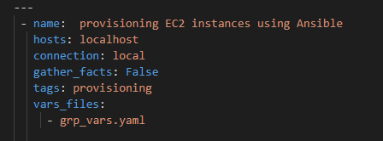

This play creates the Security Group for the webservers. It allows ports 22(SSH), 8080(HTTP Alternate), and port 80(HTTP) as inbound traffic and all traffic as outbound.

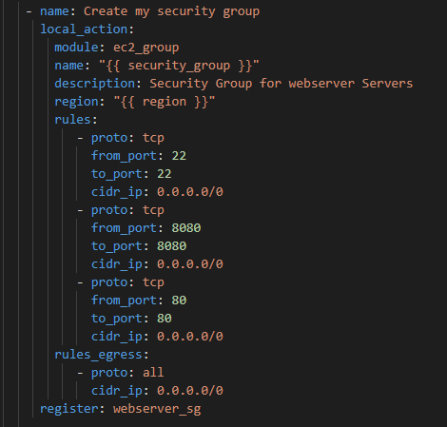

This play creates the Load Balancer and only listens to the HTTP port(port 80). I made it have two AP Zones as one will be a backup.

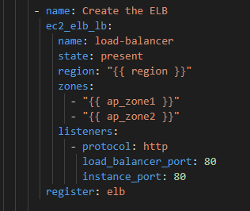

This play creates the EC2 instance and installs apache webserver into the instance. These are my web servers. The play will search for the file that has the Apache install script and will install it.

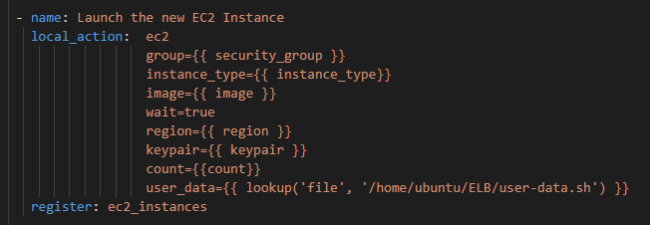

After the EC2s are created, I made a play to tag the instances.

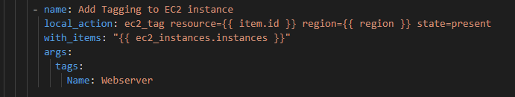

This play will then add each EC2 webserver to the ELB.

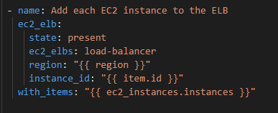

A play to just give the servers some time before moving ahead.

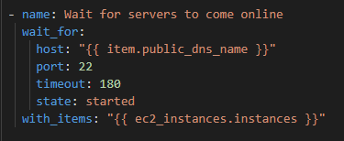

A play to then add the web server IPS to the host group

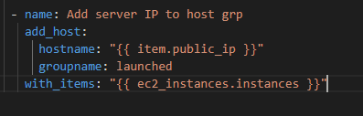

# Other Files

## Grp_vars.yaml (Variables file)

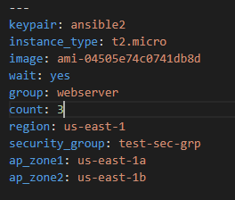

## Gather Facts file (get_facts.yml)

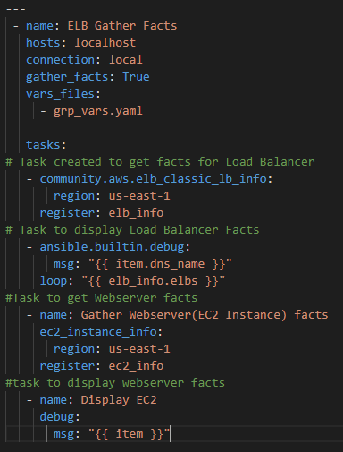

## Install Apache script (user-data.sh)

